**TCS Stock Data – Live and Latest**

**Project Report**

INDUSTRIAL TRAINING (ECS591)

Degree

**BACHELOR OF TECHNOLOGY (CSE)**

|  |  |
| --- | --- |
| PROJECT GUIDE:  **DR. NAMIT GUPTA** | SUBMITTED BY:  **LAKSHYA JAIN (TCA2309120)** |

December, 2025



**COLLEGE OF COMPUTING SCIENCES& INFORMATION TECHNOLOGY**

**TEERTHANKER MAHAVEER UNIVERSITY, MORADABAD**

**ACKNOWLEDGEMENT**

I would like to express my sincere gratitude to **TCS**  for giving me the opportunity to work on the project *“TCS Stock Analysis Dashboard”* and for providing a platform that enhanced my practical knowledge in data analytics and visualization. I am extremely thankful to my project guide and faculty mentor for their valuable guidance, continuous support, and constructive feedback throughout the development of this project.

My heartfelt thanks go to the **Head of the Department** and all the faculty members of the **Computer Science Department** for their encouragement, technical insights, and academic assistance during the project duration. I am also grateful to my classmates and friends for their cooperation and timely help at various stages of this work.

Above all, I would like to express my deepest gratitude to my **parents** for their constant motivation, support, and belief in me, which has always been my biggest source of strength.

**LAKSHYA JAIN**  
**Place:** TMU, Moradabad  
**Date:** 10-12-2025

**DECLARATION**

We hereby declare that this Project Report titled _ TCS Stock Data – Live and Latest submitted by us and approved by our project guide, DR. NAMIT GUPAT the College of Computing Sciences and Information Technology (CCSIT), Teerthanker Mahaveer University, Moradabad, is a bonafide work undertaken by us and it is not submitted to any other University or Institution for the award of any degree diploma / certificate or published any time before.

|  |  |  |
| --- | --- | --- |
| **Project Group :** | TCS Stock data –Live and Latest | |
| **Student Name:** | Lakshya Jain |  |
|  |  |  |
|  |  |  |
|  |  |  |
| **Project Guide: (External)** |  |  |
| **Project Guide: (Internal)** | Dr. Namit Gupta |  |

**Brief About the Company**

Dyizan Academy is a modern **Education Technology (EdTech) and career development organization** established with the objective of bridging the gap between academic learning and industry expectations. In today’s rapidly evolving job market, traditional education often emphasizes theoretical knowledge while lacking sufficient practical exposure. Dyizan Academy addresses this gap by focusing on **skill-based, application-oriented, and outcome-driven learning**. The organization aims to prepare students and young professionals to meet real-world industry challenges with confidence and competence.

Dyizan Academy operates as an online learning and professional training platform, providing learners with industry-relevant knowledge, hands-on project experience, and career guidance. The Academy positions itself as a forward-thinking alternative to conventional education models by prioritizing **practical skills, execution, and employability** over rote learning and degrees alone.

### ****Nature of the Organization****

Dyizan Academy functions as a **training and career acceleration platform**. Its core activities include:

* Skill development and professional training
* Internship and project-based learning programs
* Career mentoring and placement assistance
* Portfolio and resume development

The organization caters to students, fresh graduates, and early-stage professionals who seek practical exposure and career readiness. Through structured programs and real-time assignments, Dyizan Academy simulates industry environments to help learners adapt to professional work culture.

### ****Vision****

The vision of Dyizan Academy is to **create a workforce that is skilled, confident, and industry-ready**. The organization aims to redefine education by shifting the focus from degrees and marks to **real-world competence, practical execution, and measurable outcomes**.

### ****Mission****

Dyizan Academy’s mission is:

* To provide industry-aligned training programs that meet current market demands
* To enable learners to build strong professional portfolios through hands-on projects
* To support career growth through mentorship, guidance, and placement assistance
* To empower students with skills that enhance employability and long-term career success

### ****Services and Programs Offered****

Dyizan Academy offers a wide range of **career-focused programs** designed to meet the needs of different learners. These include training and internship programs in domains such as:

* Software Development (Full Stack Development)
* Data Science and Artificial Intelligence
* Digital Marketing
* Product Management
* Business Operations and Management
* Human Resources and Talent Acquisition

Each program is structured to provide both **theoretical understanding and practical application**, ensuring that learners gain real-world exposure. The curriculum is regularly updated to reflect industry trends and technological advancements.

### ****Learning Methodology****

The Academy follows a **project-based and experiential learning approach**. Instead of relying solely on lectures, learners are encouraged to work on real-time tasks, assignments, and case studies that resemble industry scenarios. This approach helps in:

* Developing problem-solving and analytical skills
* Enhancing technical and professional competencies
* Understanding workplace expectations and deadlines
* Improving teamwork and communication skills

Dyizan Academy also emphasizes portfolio development, allowing learners to showcase their work to potential employers. This practical exposure helps students stand out in a competitive job market.

### ****Career Development and Placement Support****

One of the major strengths of Dyizan Academy is its **career support system**. The organization assists learners in various aspects of career development, including:

* Resume building and professional profile optimization
* Interview preparation and mock interviews
* Career counseling and mentorship
* Internship and placement assistance

By combining skill training with career guidance, Dyizan Academy ensures that learners are not only trained but also well-prepared to enter the professional world.

### ****Organizational Culture and Values****

Dyizan Academy promotes a culture of **continuous learning, innovation, and accountability**. The organization encourages learners and interns to take ownership of their work, maintain discipline, and strive for excellence. Emphasis is placed on professionalism, ethical practices, and collaborative learning.

The Academy values:

* Practical knowledge over theoretical learning
* Skill mastery over certifications
* Continuous improvement and adaptability
* Learner success and employability

### ****Conclusion****

In conclusion, Dyizan Academy is a progressive EdTech organization that plays a significant role in shaping career-ready professionals. Through its industry-aligned programs, hands-on learning approach, and strong career support system, the Academy successfully bridges the gap between education and employment. Its focus on practical skills, real-world exposure, and professional development makes it a valuable platform for students and interns seeking meaningful career growth.

Dyizan Academy’s commitment to skill development and employability positions it as a reliable and innovative institution in the modern education ecosystem.

Table of Contents

1 Project Title 6

2 Problem Statement 6

3 Project Description 6

3.1 Scope of the Work 6

3.2 Project Modules 6

3.3 Context Diagram (High Level) 6

4 Implementation Methodology 6

5 Technologies to be used 6

5.1 Software Platform 6

5.2 Hardware Platform 7

5.3 Tools, if any 7

6 Advantages of this Project 7

7 Assumptions, if any 7

8 Future Scope and further enhancement of the Project 7

9 Project Repository Location 7

10 Definitions, Acronyms, and Abbreviations 8

11 Conclusion 8

12 References 9

**Appendix**

**A:Data Flow Diagram (DFD)**

**B:Entity Relationship Diagram (ERD)**

**C:Use Case Diagram (UCD)**

**D:Data Dictionary (DD)**

**E: Screen Shots**

# Project Title

TCS Stock Data – Live and Latest

# Problem Statement

Stock market data is highly dynamic and influenced by multiple economic and company-specific factors, making it challenging for investors and analysts to interpret without proper analytical tools. Tata Consultancy Services (TCS), being a major IT organization, has significant stock market visibility, and understanding its price movements is essential for informed investment decisions.

Despite the availability of raw historical stock data, it is often difficult to extract meaningful insights directly from spreadsheets or unprocessed files. Investors require clear visualizations, trend analysis, and interactive tools to study stock patterns effectively.

This project was undertaken to address this gap by analyzing TCS stock history and developing an interactive dashboard that simplifies complex data into easy-to-understand charts and indicators. By performing data cleaning, exploratory analysis, and visualization, the project helps users identify trends, observe fluctuations, and make more informed decisions. The goal is to provide a practical, data-driven tool that enhances understanding of stock performance and assists in financial analysis.

# Project Description

The project **“TCS Stock Analysis Dashboard – Analyze Historical Data and Visualize Market Trends”** focuses on examining historical stock data of Tata Consultancy Services (TCS) and presenting meaningful insights through an interactive dashboard. It enables users to understand stock behavior by visualizing price movements, trading volumes, and trend patterns. The system simplifies complex stock data and assists investors or analysts in making informed financial decisions.

The project includes multiple stages such as dataset preprocessing, exploratory data analysis, trend visualization, and dashboard creation. Historical stock data is cleaned, analyzed, and represented using charts like line plots and candlestick graphs. The Streamlit-based dashboard provides an intuitive interface where users can explore stock trends, observe fluctuations, and interpret market performance without requiring technical expertise.

A high-level Context Diagram illustrates the interaction between the user, the dashboard, and the underlying analysis modules. It highlights how the raw dataset flows into the preprocessing and analysis components, and how the processed insights are delivered back to the user for better understanding and decision support.

## Scope of the Work

### ****In-Scope****

1. Collecting and using historical TCS s tock data for analysis.
2. Preprocessing the dataset, including cleaning, handling missing values, and organizing date-based records.
3. Performing Exploratory Data Analysis (EDA) to identify trends, patterns, and key stock indicators.
4. Visualizing stock behavior using charts such as line plots, candlestick charts, and moving averages.
5. Developing an interactive Streamlit dashboard to display insights and allow users to explore stock trends.
6. Providing descriptive insights based on historical data to support interpretation and decision-making.
7. Implementing basic statistical and visual techniques to understand market fluctuations.

### ****Out of Scope****

1. Real-time stock market data fetching or live data streaming.
2. Advanced predictive modeling or machine learning–based stock price forecasting.
3. Financial risk assessment, portfolio optimization, or investment advisory services.
4. Analysis of multiple companies or sectors beyond TCS stock data.
5. Integration with external trading platforms or automation of stock transactions.
6. Any commercial or trading-related recommendations based on the analysis.

## Project Modules

The project is organized into several functional modules, each responsible for handling a specific part of the stock analysis and dashboard workflow. These modules work together to process the dataset, generate insights, and present them through an interactive interface.

### ****Data Preprocessing Module****

**Functions:**

* Load the historical TCS stock dataset.
* Clean and format the data (handle missing values, adjust date formats).
* Prepare structured data for analysis and visualization.

This module ensures that only accurate and consistent data is passed to the analysis component.

### ****Exploratory Data Analysis (EDA) Module****

**Functions:**

* Analyze stock parameters such as Open, Close, High, Low, and Volume.
* Generate summary statistics and identify key patterns in stock performance.
* Interpret trends such as daily, monthly, or yearly changes.

This module helps users understand the overall behavior and volatility of the stock.

### ****Visualization Module****

**Functions:**

* Create graphical representations including line charts, candlestick charts, moving averages, and volume plots.
* Highlight key patterns, peaks, dips, and fluctuations visually.
* Support comparative visual analyses over different time periods.

This module converts raw numerical data into intuitive visual insights.

### ****4. Interactive Dashboard Module (Streamlit Interface)****

**Functions:**

* Provide a user-friendly interface to explore stock trends interactively.
* Display charts, statistics, and analysis results in an organized layout.
* Allow users to navigate between different sections such as Trend Analysis, Price Overview, Volume Insights, etc.
* Manage menu navigation and dynamic chart rendering based on user selection.

This module forms the main interaction point for the user, making the analysis accessible and easy to interpret.

### ****Main Menu and Navigation****

The dashboard includes a **main menu** that allows users to move through different sections of the application. Users can:

* Select the type of chart or visualization.
* Choose time ranges or specific parameters for analysis.
* Navigate across key modules such as Data Overview, Price Trends, and Visual Analysis.

The menu structure ensures smooth movement between modules without restarting the application.

## Context Diagram (High Level)

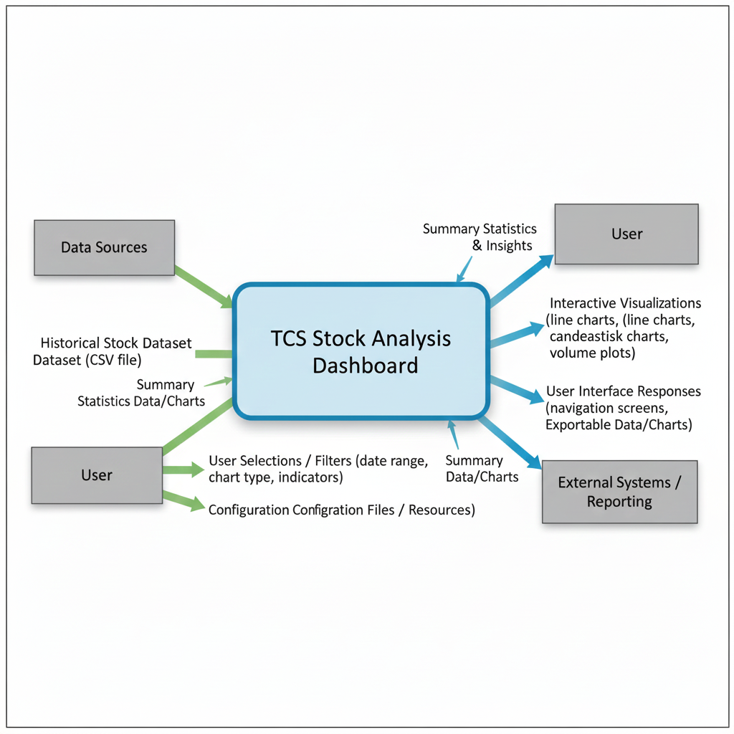

# Implementation Methodology

The development of the TCS Stock Analysis Dashboard follows a structured methodology that includes data preprocessing, analysis, visualization, dashboard development, and testing. The overall process ensures that raw stock data is transformed into meaningful insights through a systematic workflow.

### ****Process Overview****

1. **Data Collection & Preprocessing**
   * Load the TCS stock dataset.
   * Clean missing values, format dates, and prepare data for analysis.
2. **Exploratory Data Analysis (EDA)**
   * Generate summary statistics and identify stock trends.
   * Visualize price movements and volume patterns.
3. **Visualization Development**
   * Create line charts, candlestick charts, moving averages, and other visual insights.
4. **Dashboard Implementation**
   * Integrate all visuals and processed data into a Streamlit-based interactive dashboard.
   * Provide menu navigation and options for users to filter and explore data.
5. **Testing**
   * Perform basic unit tests (data loading, preprocessing functions).
   * Conduct UI testing to ensure charts render properly and navigation works smoothly.
   * Log defects, fix errors, and retest for accuracy.
6. **Maintenance**
   * Maintain a simple defect log to track issues found during development and testing.
   * Update or refine modules as required.

# Technologies to be used

## ****Software Platform****

#### ****a) Front-end****

* **Streamlit Framework** – used to build the interactive web-based dashboard interface.
* **Plotly / Matplotlib Libraries** – used to generate visual charts such as line graphs, candlestick charts, and volume plots.
* **HTML/CSS (auto-generated by Streamlit)** – for rendering the UI components.

#### ****b) Back-end****

* **Python 3.x** – core programming language for data processing, analysis, and visualization.
* **Pandas & NumPy** – used for data cleaning, transformation, and mathematical computations.
* **Jupyter Notebook** – used for exploratory data analysis and experimenting with data models.
* **CSV File Storage** – dataset stored in .csv format (TCS_stock_history.csv).

## ****5.2 Hardware Platform****

* **RAM:** Minimum 4 GB (8 GB recommended)
* **Hard Disk:** 1 GB free space for dataset, libraries, and project files
* **Processor:** Dual-core or higher
* **Operating System:** Windows 10 / Windows 11 / Linux / macOS
* **Code Editor:**
  + Visual Studio Code
  + Jupyter Notebook / JupyterLab
* **Browser:** Google Chrome / Microsoft Edge / Mozilla Firefox
* **Optional:** Internet connection for installing Python packages and Streamlit components.

## ****5.3 Tools Used****

| **Tool Name** | **Vendor** | **Version** | **Purpose** |
| --- | --- | --- | --- |
| **Python** | Python Software Foundation | 3.x | Core programming language for data handling and analysis |
| **Streamlit** | Streamlit Inc. | Latest | Building and deploying the interactive dashboard |
| **Pandas** | Open Source | Latest | Data cleaning, preprocessing, and analysis |
| **NumPy** | Open Source | Latest | Mathematical operations and array processing |
| **Matplotlib / Plotly** | Open Source | Latest | Visualization of stock trends and charts |
| **Jupyter Notebook** | Project Jupyter | Latest | Exploratory data analysis, testing, and prototyping |
| **Git (Optional)** | Git SCM | Latest | Version control during development |
| **VS Code** | Microsoft | Latest | Code writing, debugging, and project management |

# Advantages of this Project

1. **Simplifies Stock Data Analysis**

The dashboard converts raw TCS stock data into easy-to-understand visual insights, making analysis accessible even for non-technical users.

1. **Improves Decision-Making**  
   Interactive visualizations help investors and analysts quickly identify market trends, price fluctuations, and performance patterns, supporting better financial decisions.
2. **User-FriendlyInterface**  
   Built using Streamlit, the dashboard provides smooth navigation, dynamic charts, and simple controls, making it intuitive for users to explore data.
3. **Time-Saving Automation**  
   Manual analysis of stock data is time-consuming. The system automates data processing and visualization, significantly reducing effort.
4. **Accurate and Consistent Results**  
   Automated processing minimizes human errors that often occur during manual calculations or chart preparation.
5. **Interactive and Customizable Views**  
   Users can apply filters such as date range, chart type, or indicators to personalize the analysis based on their needs.
6. **Flexible and Scalable Design**  
   The system can easily be extended to include more indicators, additional companies, predictive analysis, or real-time data in the future.
7. **Open-Source and Cost-Effective**  
   The project uses free, open-source tools like Python, Pandas, and Streamlit, ensuring low development and maintenance costs.
8. **Supports Learning and Research**  
   The dashboards and visualizations help students, researchers, and beginners understand stock market behavior and data analysis techniques.

# Assumptions, if any

1. The historical TCS stock dataset used in the project is accurate, complete, and free from major inconsistencies.
2. Users accessing the dashboard have a basic understanding of stock market terms such as Open, Close, High, Low, and Volume.
3. The system will be used for analysis and educational purposes, not for real-time trading or financial advising.
4. The dashboard will run on a system with the required software and hardware specifications installed

# Future Scope and further enhancement of the Project

The current TCS Stock Analysis Dashboard provides a solid platform for analyzing historical stock data and visualizing market trends. This section outlines how the project can be enhanced in terms of functionality, analytics capability, usability, and real-world integration to evolve into a more advanced stock intelligence and market analysis tool.

## ****8.1 Functional Enhancements****

| **Area** | **Enhancement** | **Benefit** |
| --- | --- | --- |
| **Advanced Analytical Models** | Introduce machine learning–based stock forecasting using ARIMA, LSTM, or Prophet models. | Enables prediction of future stock prices to support informed investment decisions. |
| **Technical Indicators Expansion** | Add indicators such as RSI, MACD, Bollinger Bands, Trend Lines, and Moving Average Crossovers. | Provides deeper insights for traders and analysts using technical analysis methods. |
| **Interactive Scenario Analysis** | Implement a “What-If” feature allowing users to simulate market conditions (e.g., volatility increase, trend reversal). | Helps investors understand potential outcomes and evaluate risk before making decisions. |
| **Multi-Stock Comparison** | Allow the dashboard to compare TCS stock with other companies or industry benchmarks. | Offers broader market context and supports comparative analysis for better insights. |
| **News & Sentiment Integration** | Include news sentiment analysis using NLP to correlate sentiment with stock movements. | Enhances analysis by linking external events to price fluctuations. |

## ****8.2 Usage and Deployment Enhancements****

1. **Real-Time Market Data Integration:**  
   Connect the dashboard to live market APIs (NSE, BSE, Yahoo Finance) to display up-to-the-minute stock prices, trends, and indicators.
2. **User Authentication and Personalized Dashboards:**  
   Implement login functionality and user-specific settings so investors can save preferred indicators, time ranges, and analysis configurations.
3. **Mobile and Tablet Optimization:**  
   Enhance UI responsiveness to ensure smooth access across mobile devices, enabling users to track stock trends on the go.
4. **Automated Data Refresh and Model Updates:**  
   Set up scheduled scripts to automatically fetch new stock data and refresh visualizations without manual intervention.
5. **Report Exporting Enhancements:**  
   Add features to export selected charts and insights into PDF, Excel, or image formats for reporting or academic use.
6. **Cloud Deployment:**  
   Host the dashboard on cloud platforms (Streamlit Cloud, AWS, Azure, or Heroku) for broader accessibility and improved scalability.
7. **Alert and Notification System:**  
   Implement threshold-based notifications (e.g., sudden price drop, moving average crossover) to alert users of important market movements.

These enhancements transform the project from a simple visualization tool into a comprehensive, intelligent stock analysis platform capable of supporting real-time market tracking, predictive modeling, and advanced financial decision-making.

# Project Repository Location

*<Guidelines: Mention the location of the latest Source Code and all related documents, like- Project Synopsis Report, Project Progress updates, Project Requirement Details, Project Report (Softcopy), Test Repository (all test scenarios, test cases etc.) used for Functional Testing of the project etc. The repository location must be somewhere in CCSIT-Lab>*

| **S#** | **Project Artifacts (softcopy)** | **Location** (Mention Lab-ID, Server ID, Folder Name etc.) | **Verified by Project Guide** | **Verified by Lab In-Charge** |
| --- | --- | --- | --- | --- |
|  | Project Synopsis Report (Final Version) |  | Name and Signature | Name and Signature |
|  | Project Progress updates |  | Name and Signature | Name and Signature |
|  | Project Requirement specifications |  | Name and Signature | Name and Signature |
|  | Project Report (Final Version) |  | Name and Signature | Name and Signature |
|  | Test Repository |  | Name and Signature | Name and Signature |
|  | Any other document, give details |  | Name and Signature | Name and Signature |

# Definitions, Acronyms, and Abbreviations

This section provides definitions and explanations of commonly used terms, acronyms, and abbreviations referenced throughout the Software Requirements Specification (SRS). These definitions ensure clarity and consistency in understanding the concepts related to the TCS Stock Analysis Dashboard. Additional terminology may be listed in the Annexure if required

### ****Abbreviation Table****

| **Abbreviation** | **Description** |
| --- | --- |
| **TCS** | Tata Consultancy Services – the company whose stock data is analyzed in this project. |
| **CSV** | Comma Separated Values – a file format used to store tabular data, such as historical stock data. |
| **EDA** | Exploratory Data Analysis – the process of analyzing data sets to summarize their main characteristics. |
| **UI** | User Interface – the visual part of the application that users interact with. |
| **API** | Application Programming Interface – a mechanism to connect software components; can be used for live data fetching. |
| **MA** | Moving Average – a technical indicator used for stock trend analysis. |
| **RSI** | Relative Strength Index – a technical indicator used to measure momentum (future enhancement). |
| **MACD** | Moving Average Convergence Divergence – a technical analysis indicator used to identify trend changes. |
| **DFD** | Data Flow Diagram – a diagram showing data movement within a system. |
| **SRS** | Software Requirements Specification – document describing system requirements. |
| **UAT** | User Acceptance Testing – testing performed by end users to validate system functionality. |
| **OS** | Operating System – software that manages computer hardware and applications. |
| **RAM** | Random Access Memory – hardware for temporary data storage needed during program execution. |
| **ML** | Machine Learning – techniques used to build predictive models (future enhancement). |
| **NLP** | Natural Language Processing – AI technique used to analyze text data (future enhancement). |

# Conclusion

The TCS Stock Analysis Dashboard effectively transforms historical stock data into clear, interactive visual insights. By automating data processing and visualization, the system reduces manual effort and minimizes errors, helping users understand stock trends more efficiently. The project meets its objectives by providing an accessible and user-friendly platform for basic financial analysis.

This dashboard is cost-effective, easy to maintain, and adaptable for future enhancements such as real-time data integration, predictive modeling, and expanded technical indicators. With its flexible and open-source nature, the system can be further developed to support more advanced investment analysis and decision-making in both academic and practical environments

# References

The following documents, tools, and sources were referenced during the development of this SRS. All references are publicly available through their respective official websites or documentation portals.

| **Title / Document** | **Publishing Organization** | **Date** | **Source** |
| --- | --- | --- | --- |
| TCS Stock History Dataset (CSV) | NSE / Yahoo Finance | Updated periodically | <https://finance.yahoo.com> |
| Python Documentation | Python Software Foundation | Latest | <https://docs.python.org> |
| Pandas & NumPy Documentation | Open Source Community | Latest | <https://pandas.pydata.org>, <https://numpy.org> |
| Matplotlib / Plotly Docs | Matplotlib Devs / Plotly Inc. | Latest | <https://matplotlib.org>, <https://plotly.com> |
| Streamlit Documentation | Streamlit Inc. | Latest | <https://docs.streamlit.io> |
| Jupyter Notebook Docs | Project Jupyter | Latest | <https://jupyter.org> |
| IEEE SRS Standard (IEEE 830) | IEEE | 1998 | Available through IEEE Digital Library |
| General Stock Market Concepts | Investopedia | Various | https://www.investopedia.com |

**Annexure A**

**Data Flow Diagram (DFD)**

**1.CONTEXT DIAGRAM(0-LEVEL DFD)**

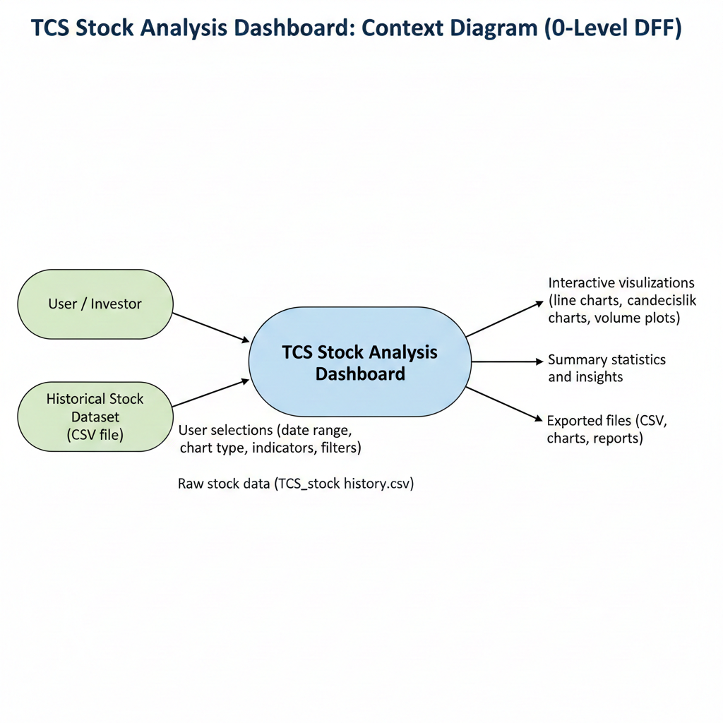

**2. LEVEL-1 DFD**

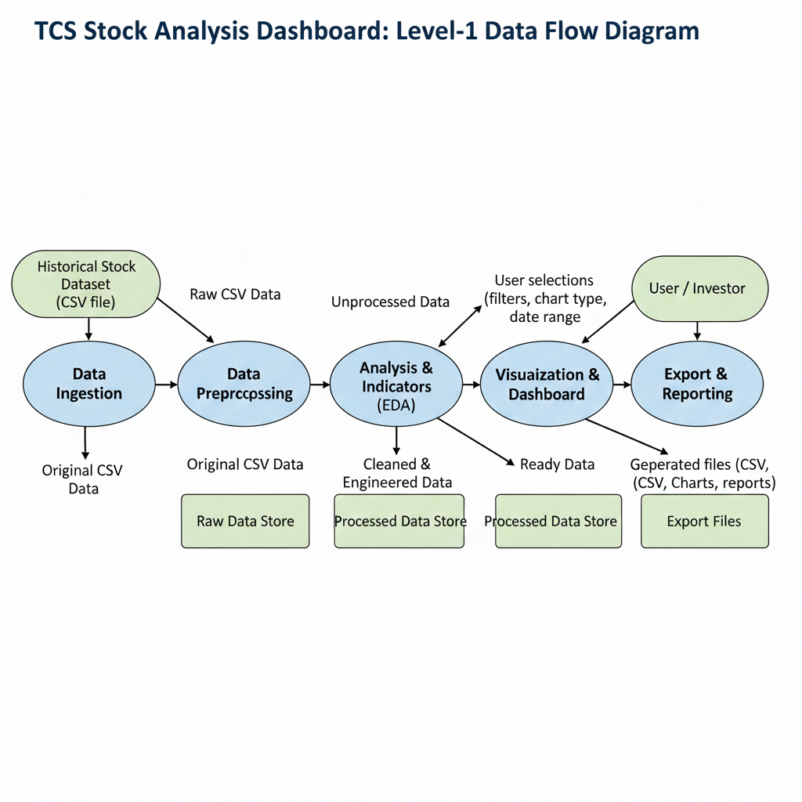

**Annexure B**

**Entity-Relationship Diagram (ERD)**

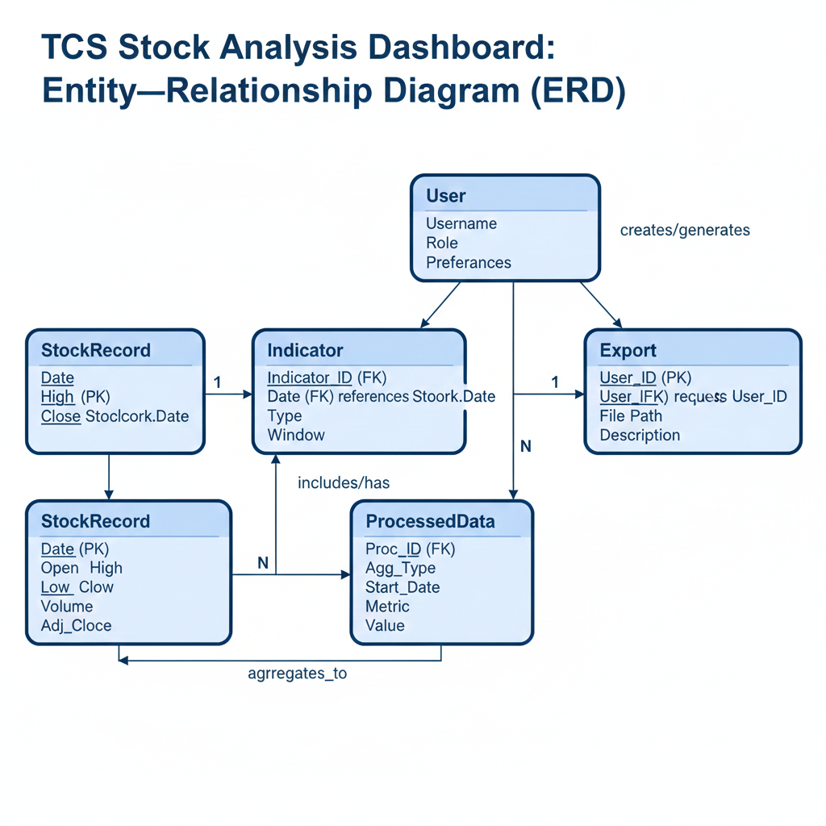

**Annexure C**

**Use-Case Diagram (UCD)**

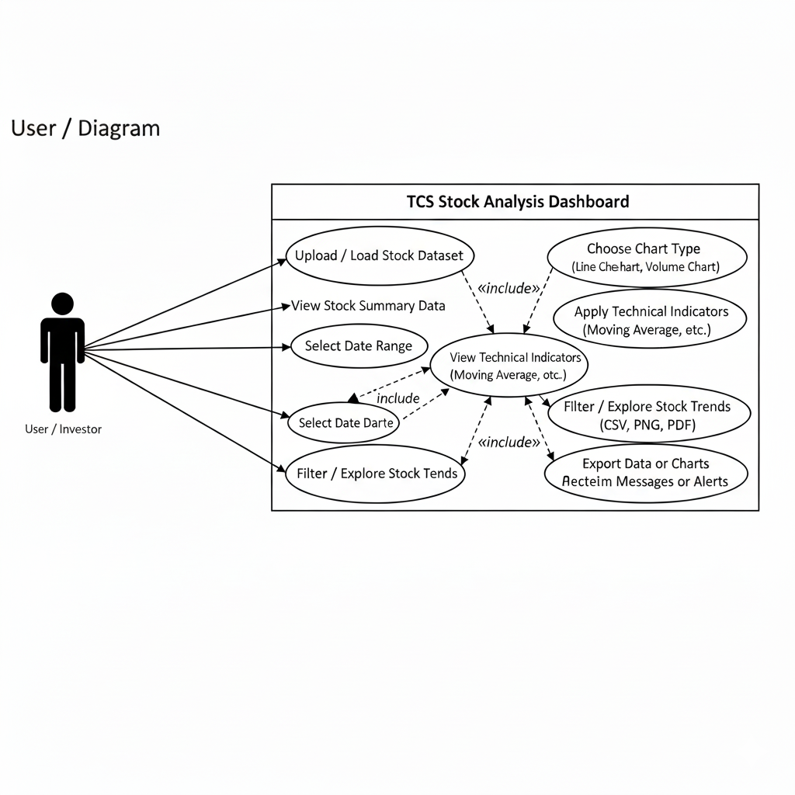

**Annexure D**

**Data Dictionary (DD)**

This Data Dictionary describes all data entities, fields, and attributes used in the **TCS Stock Analysis Dashboard**.

## ****1. StockRecord Table (STOCK)****

| **Field Name** | **Data Type** | **Description** |
| --- | --- | --- |
| STOCK-Date | Date | Trading date (Primary Key) |
| STOCK-Open | Number | Opening price of TCS stock |
| STOCK-High | Number | Highest price on trading day |
| STOCK-Low | Number | Lowest price on trading day |
| STOCK-Close | Number | Closing price of the day |
| STOCK-AdjClose | Number | Adjusted closing price after corporate actions |
| STOCK-Volume | Number | Number of shares traded |

## ****2. Indicator Table (IND)****

| **Field Name** | **Data Type** | **Description** |
| --- | --- | --- |
| IND-ID | Number | Unique indicator ID (Primary Key) |
| IND-Date | Date | Date of indicator calculation (Foreign Key → STOCK-Date) |
| IND-Type | Text | Indicator type (MA, RSI, MACD, etc.) |
| IND-Window | Number | Time window/period (e.g., 20 days) |
| IND-Value | Number | Computed value of the indicator |

## ****3. Processed Data Table (PROC)****

| **Field Name** | **Data Type** | **Description** |
| --- | --- | --- |
| PROC-ID | Number | Unique processed-data ID |
| PROC-Agg-Type | Text | Aggregation type (daily, weekly, monthly) |
| PROC-Start-Date | Date | Start date for aggregated data |
| PROC-End-Date | Date | End date for aggregated data |
| PROC-Metric | Text | Metric used (avg_close, total_volume, etc.) |
| PROC-Value | Number | Final aggregated value |

## ****4. User Table (USR)**** (Optional)

| **Field Name** | **Data Type** | **Description** |
| --- | --- | --- |
| USR-ID | Number | Unique user ID |
| USR-Username | Text | Username of the dashboard user |
| USR-Role | Text | Role assigned (analyst, investor) |
| USR-Preferences | Text | Stored user settings or preferences |

## ****5. Export Table (EXP)****

| **Field Name** | **Data Type** | **Description** |
| --- | --- | --- |
| EXP-ID | Number | Export entry ID |
| EXP-User-ID | Number | Linked user (Foreign Key → USR-ID) |
| EXP-Type | Text | Export type (CSV, PDF, PNG) |
| EXP-Request-Date | Date/Time | Timestamp of export action |
| EXP-File-Path | Text | Storage path of exported file |
| EXP-Description | Text | Additional export notes |

**Annexure E**

**Screen Shots**

**Home Page:**

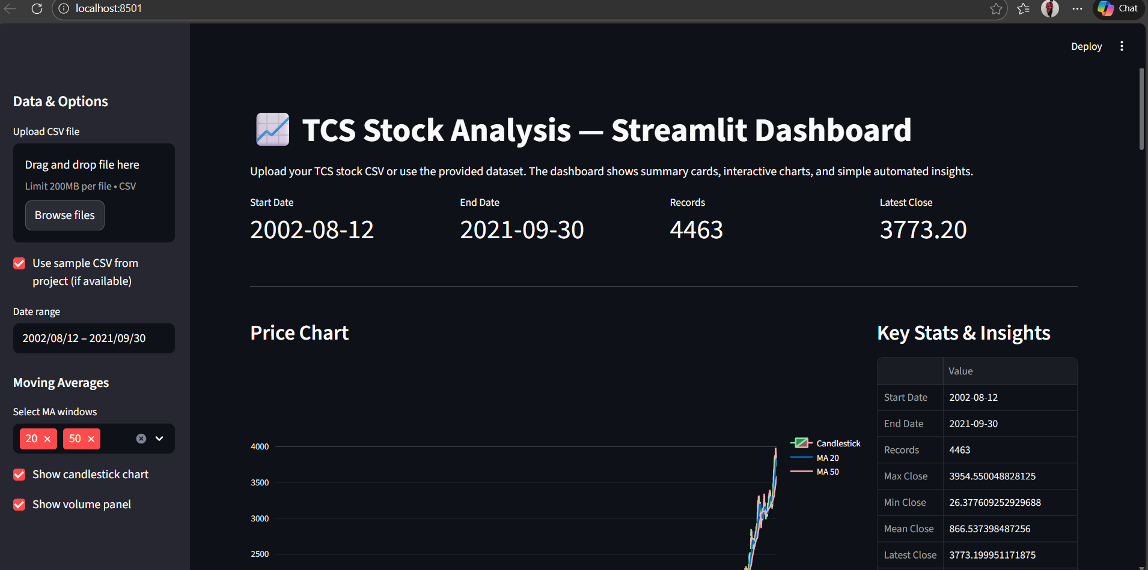

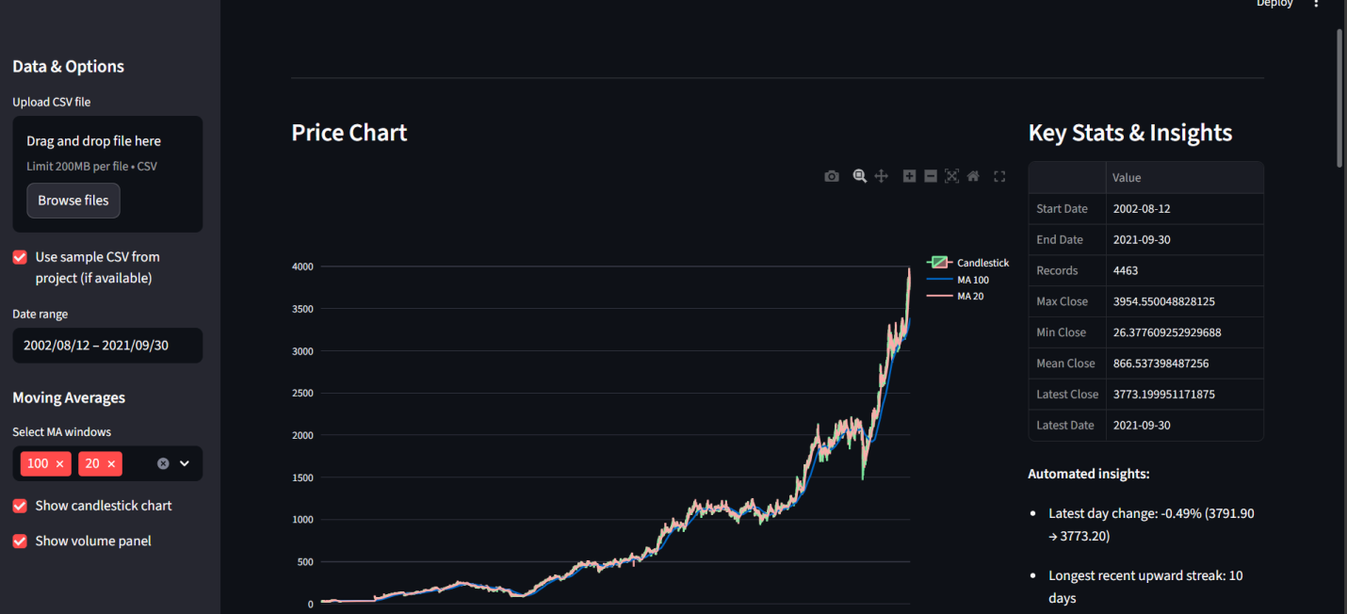

***GRAPHS***